Edge Intelligence

-JAYAENTH KANNA V

25MML0056

Aim
To capture video using OpenCV and perform basic image processing operations such as drawing shapes, edge detection, negative transformation, and motion detection.

Tools Required
- Python
- OpenCV Library
- Jupyter Notebook / Google Colab
- Webcam

Procedure
- Import the OpenCV library.
- Capture video from the webcam using VideoCapture().
- Display frames using cv2.imshow().
- Draw shapes such as rectangles and circles on the frame.
- Apply Canny edge detection to detect object boundaries.
- Perform negative image transformation.
- Detect motion using frame difference technique.

Operations Performed
1. Webcam Video Capture
Live video is captured from the webcam and displayed frame by frame.
2. Drawing Shapes
Rectangle and circle are drawn on the video frame using OpenCV functions.
3. Canny Edge Detection
The Canny algorithm detects edges of objects in the frame.
4. Negative Image Transformation
Pixel values are inverted using the formula:
S = 255 − R
5. Motion Detection
Motion is detected by comparing two consecutive frames.

Result
Video was successfully captured using OpenCV and image processing techniques such as shape drawing, edge detection, negative transformation, and motion detection were performed successfully.

1. Webcam Video Capture:

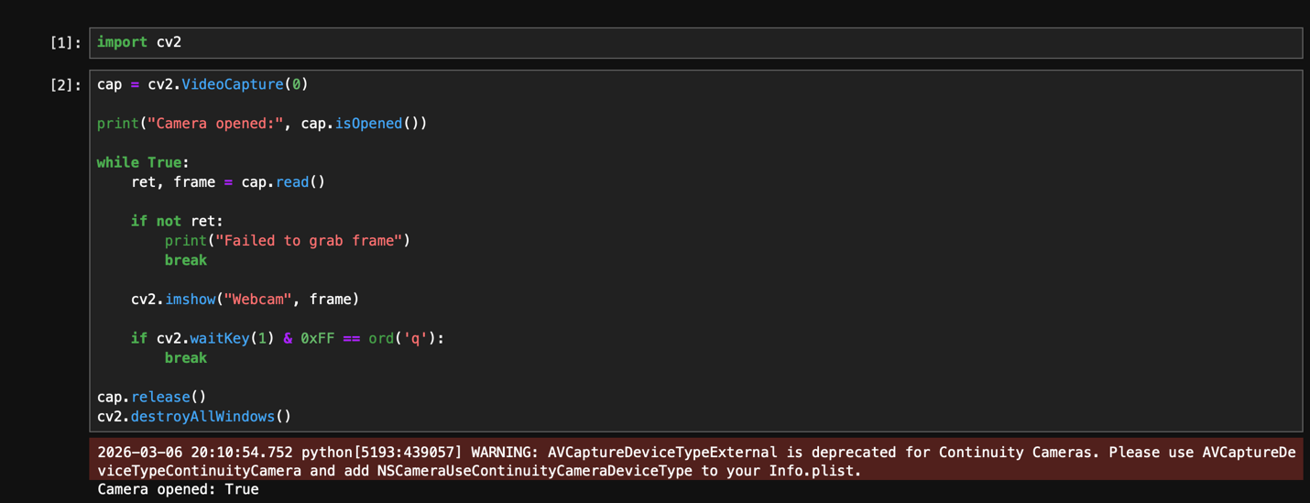

2. Drawing Shapes (Rectangle & Circle)

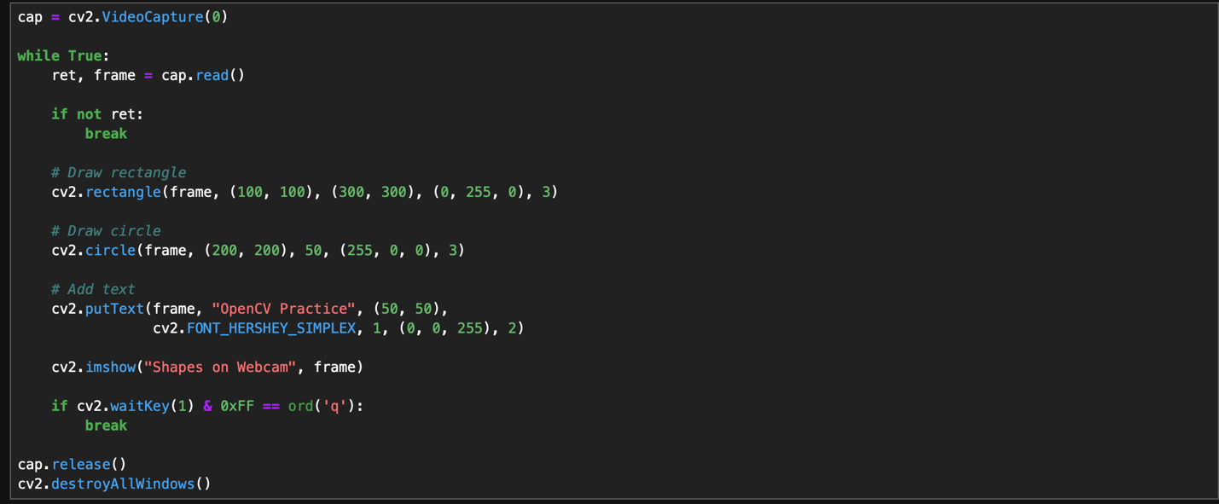

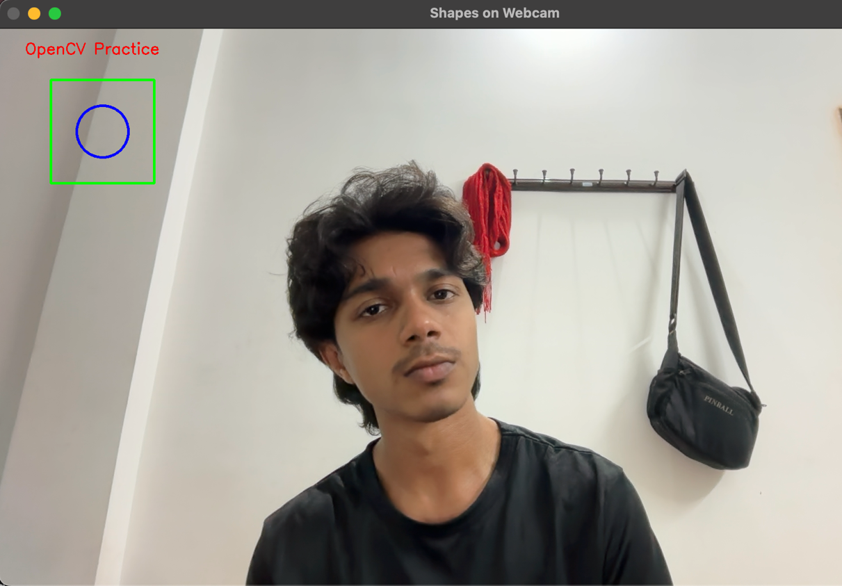

3. Canny Edge Detection

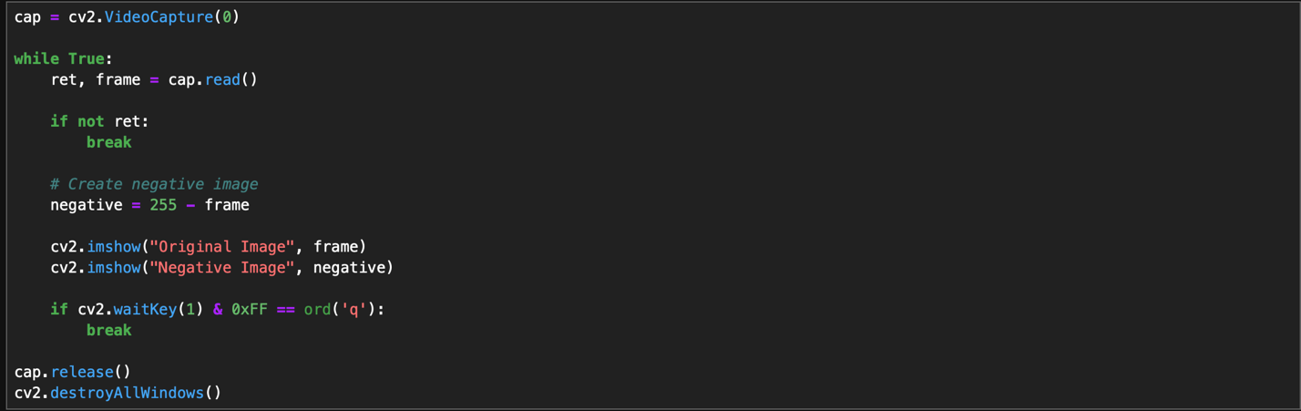

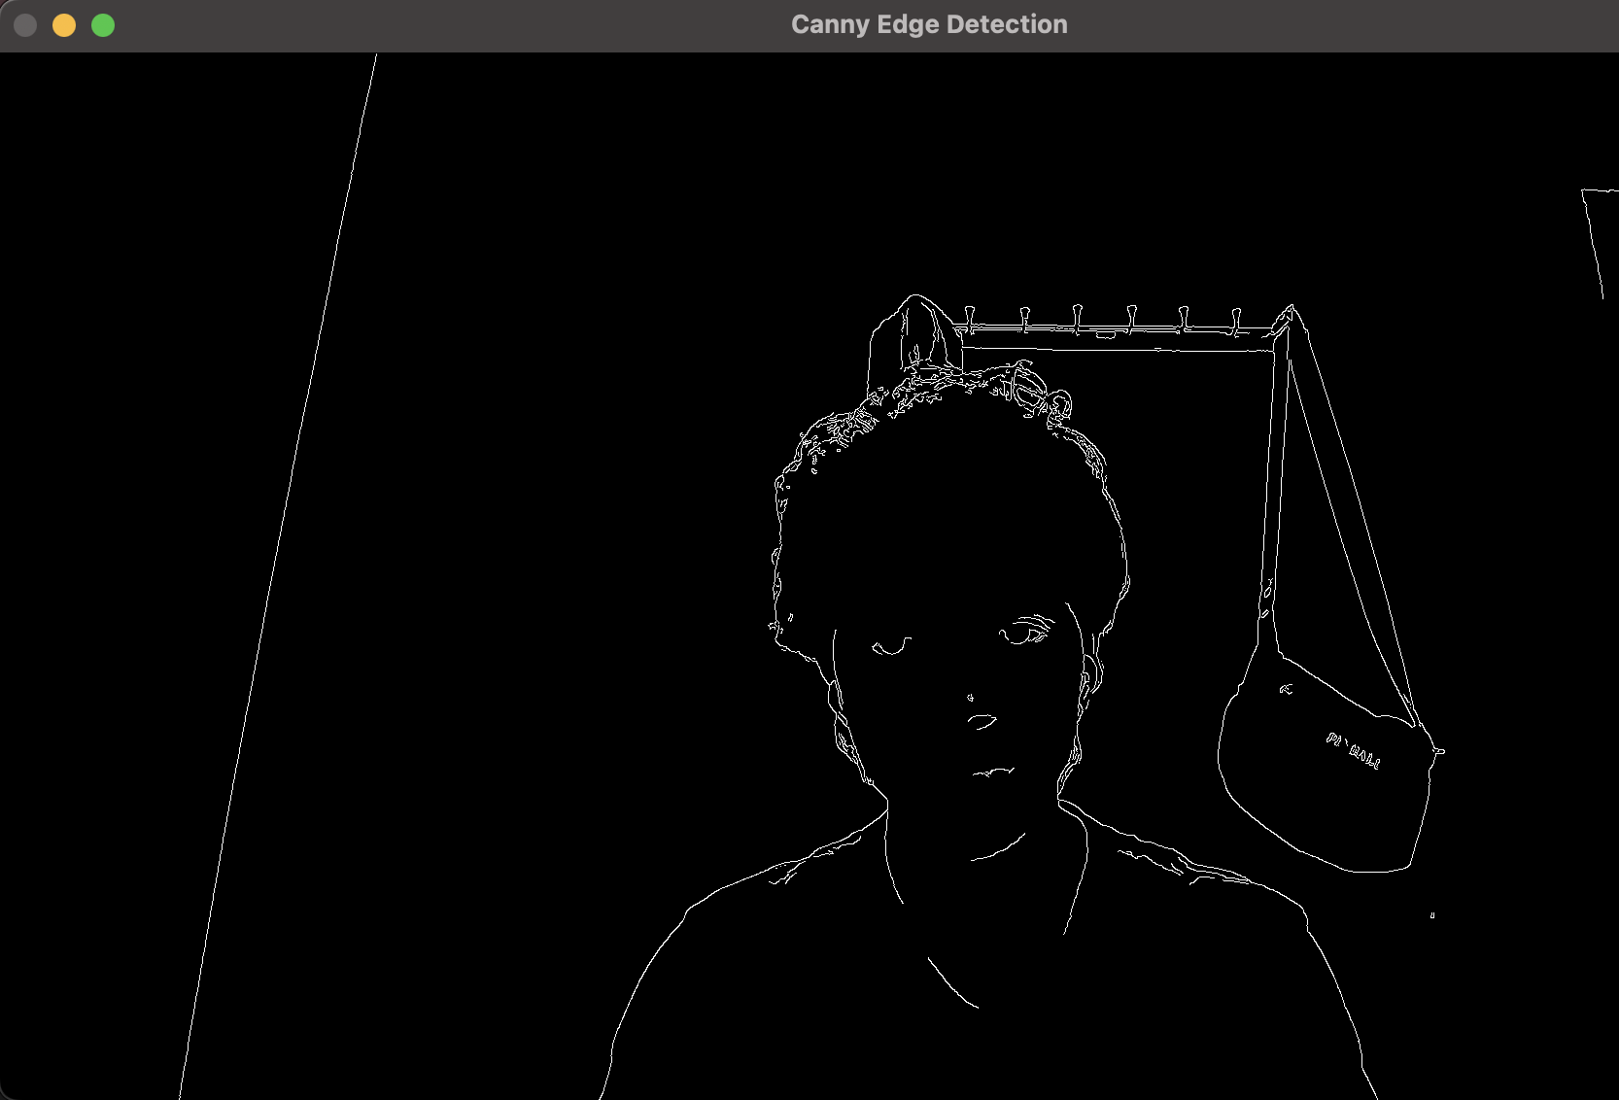

4. Negative Image Transformation

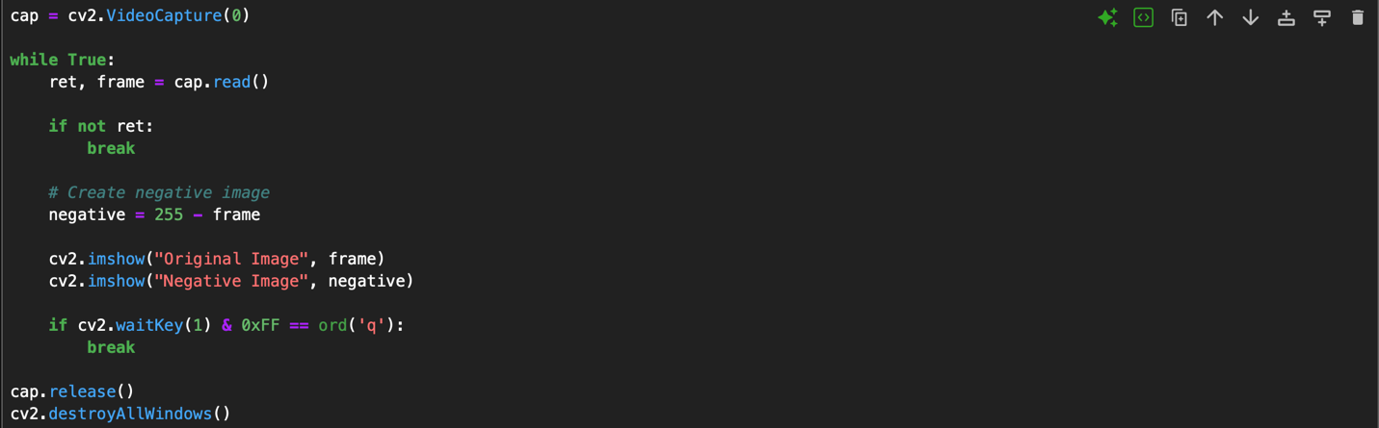

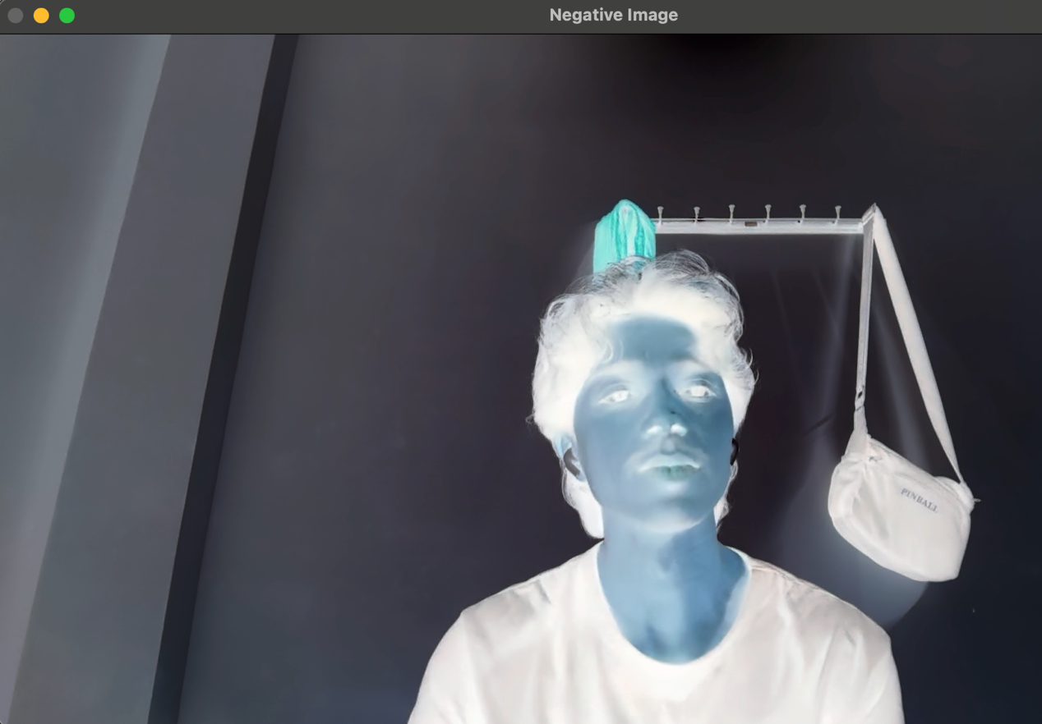

5. Motion Detection

